Name | Raj Kalpesh Mathuria
UID no. | 2023300139

Experiment no.
AIM : | Linear Regression
Theory: | Theory: Linear Regression  Linear Regression is a statistical method to model the relationship between a dependent variable (y) and one or more independent variables (X).  - Simple Linear Regression (SLR): Uses one feature to predict the target.  - Equation: y=β0​+β1​x+ϵ  - Goal: Find the "line of best fit" that minimizes the squared difference between predicted and actual values.  - Multiple Linear Regression (MLR): Uses multiple features to predict the target.  - Equation: y=β0​+β1​x1​+β2​x2​+...+βn​xn​+ϵ  - Goal: Find the "hyperplane" that fits the data best.  The term ϵ (epsilon) represents noise or error, simulating real-world randomness that prevents a perfect fit. We created a controlled environment to test the Linear Regression algorithm:  - Generation: We generated synthetic data using known "secret" coefficients (e.g., Slope=2.5) defined in config.py.  - Noise Injection: We added random Gaussian noise (NOISE_LEVEL) so the data wouldn't be perfectly linear.  - Training: We fed this noisy data into the model without telling it the secret coefficients.  - Verification: We checked if the model could "discover" the original coefficients on its own.
Code: | https://github.com/CodeCraftsmanRaj/ML_Sem6
OUTPUT: | 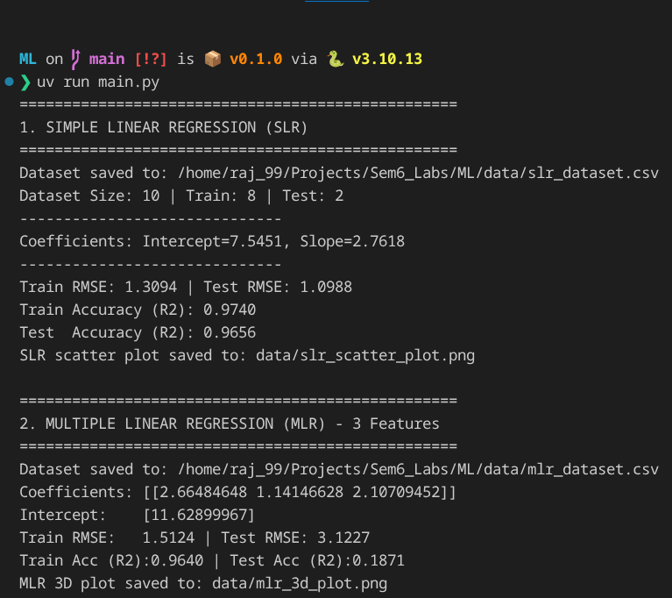  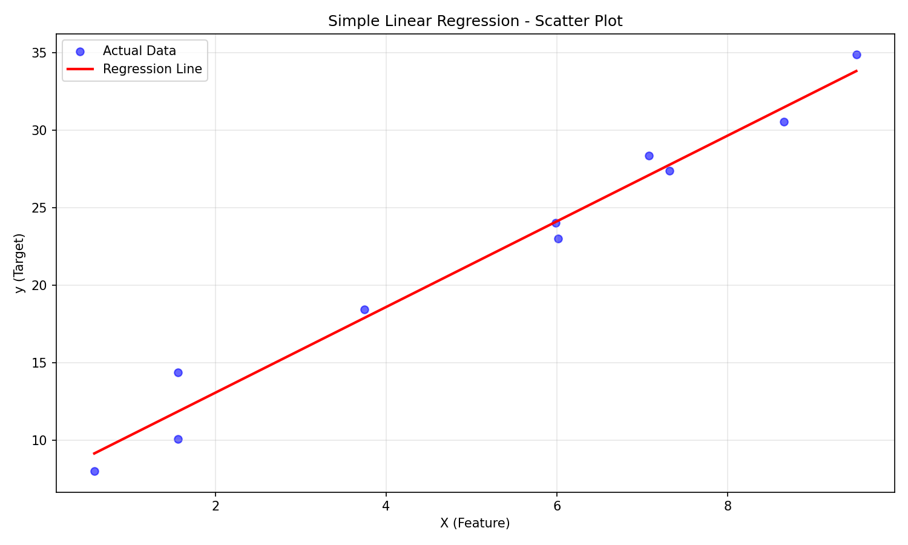  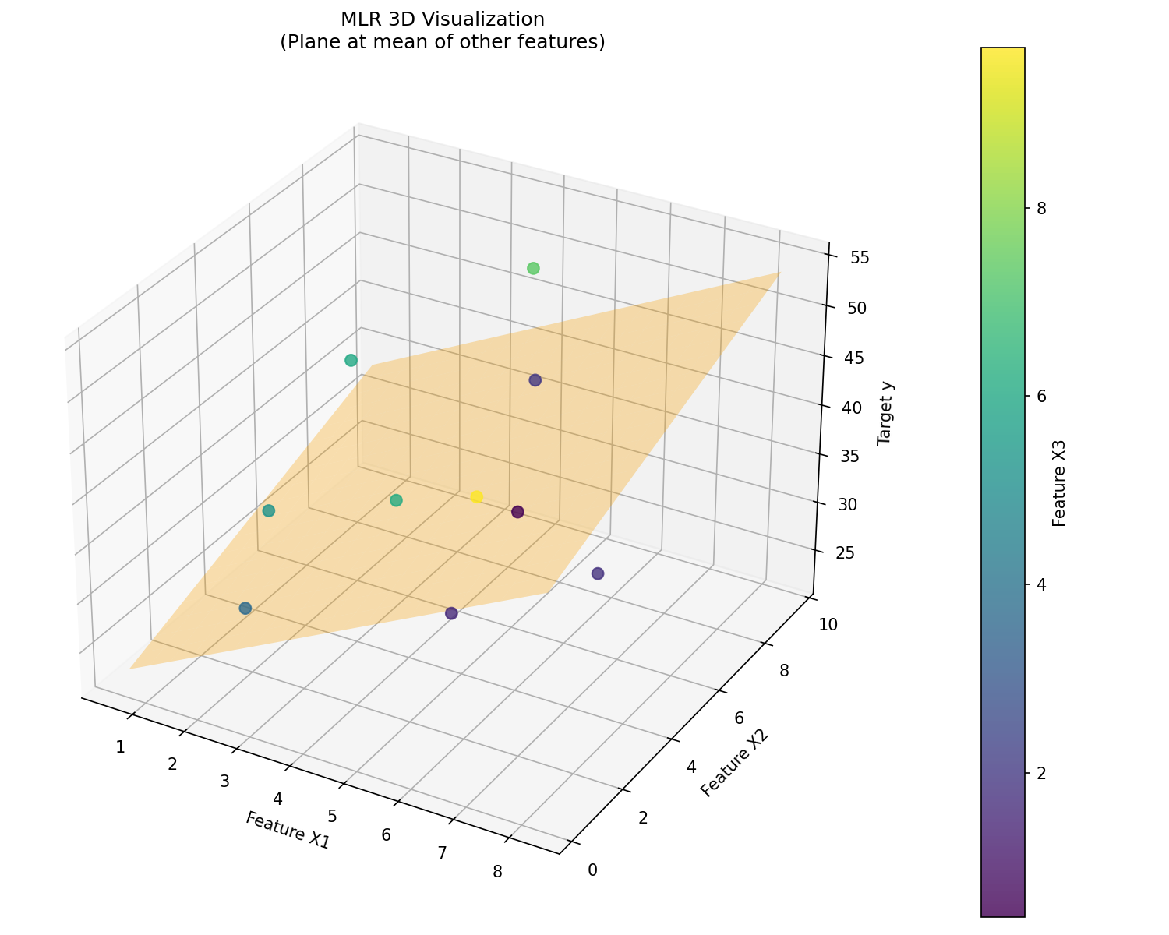
CONCLUSION: | High Accuracy with Small Data: Despite using a very small dataset (10 samples), both models achieved excellent accuracy (R2>0.96). This shows Linear Regression is robust and efficient even with limited data.  - Noise Impact: The learned SLR coefficients (Intercept ≈ 7.5, Slope ≈ 2.76) deviated slightly from the true values (10 and 2.5). This is expected because with only 8 training points, the random noise (RMSE≈1.3) skews the "line of best fit" slightly away from the perfect theoretical line.  - Generalization: The Test accuracy (R2≈0.96 for SLR, 0.99 for MLR) was surprisingly close to or better than Train accuracy. This indicates the model generalized  well and didn't simply memorize the noise in the training data, though the extremely low Test RMSE in MLR suggests the test set happened to be "easy" (points fell very close to the line by chance).

Submit on Moodle before the Deadline and in PDF format only.

